THE FRIENDS OF NIXON MEMORIAL HOSPITLAL SIERRA LEONE
Registered UK Charity no. 1145455 www.Friendsofnixon.org.uk
–the life line for around 30,000 people urgently needs support.
Beginnings Almost 80 years ago a British Methodist Minister was appointed to work at Segbwema, a Sierra Leonean town 250 miles up-country from the capital, Freetown. His wife was a nurse who started treating the sick on the veranda h of their simple bungalow. From those early beginnings the Nixon Memorial Hospital came into being. The hospital is part of the Methodist Church in Sierra Leone and has been and is to the present day greatly supported by the Methodist Church in UK.
History The Nixon Hospital gradually developed to become a centre of clinical excellence , widely known throughout Sierra Leone for he excellent medical care provided for children and adults together with areas of specialist care. There was also a widely acclaimed nursing school.
Then came the appalling and pointless civil war. At first the hospital staff carried on – at risk, often with no salary but then the rebels over-ran the hospital - the staff had to flee for their lives Since the war gradually some re-building has taken place but THE HOSPITAL IS RELIANT TO A LARGE EXTENT ON WHAT PEOPLE CAN PAY FPOR THEIR TREATMENT --- IN AN AREA OF GREAT POVERTY
What in needed ? What does she need ? ---one of the first babies to be born at the hospital at Nixon after the war 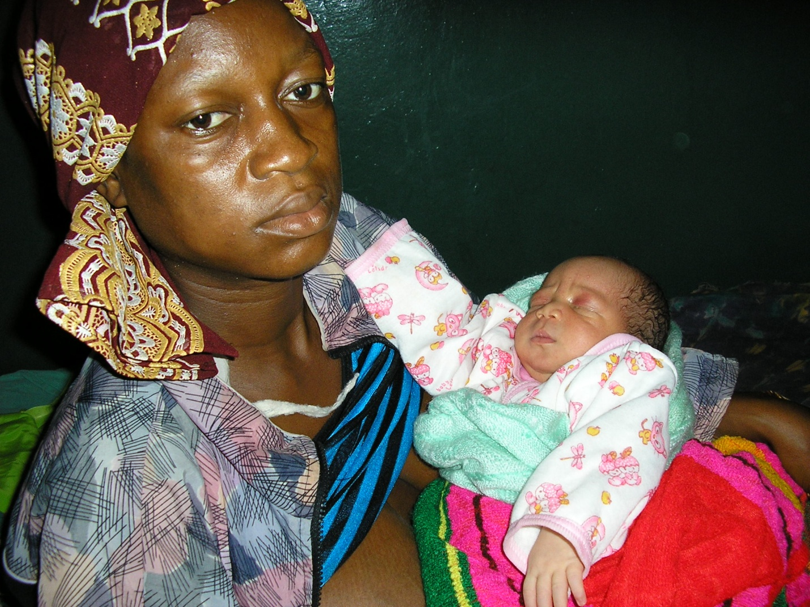
THE VISION FOR THE FUTURE is for Nixon to be an effective community hospital -- serving the needs of the 30,000 people in its catchment area where there is little health care provision except through the hospital and babies like this have a 1 in 5 chance of dying before the age of 5
To this end the charity “Friends of Nixon” (F of N) has been established A UK Bank account has been opened at Lloyds and a dedicated bank account will soon be opened in Sierra Leone. When applications are received from the management group at the hospital and approved by the trustees then money will be capable of being directly transferred to the “Friends of Nixon” account in Sierra Leone.
If you are able to make a donation please fill in the attached form together with the accompanying cheque made payable to “The Friends of Nixon” and post it to the treasurer Mr Robert Dixon –address below He will also be glad to receive any standing order agreements and if you are a UK tax payer please fill in the gift aid section
“Friends of Nixon” Notting Hill Methodist Church 240, Lancaster Road London w11 4AH
On behalf of the people in the Njaluhan Chiefdom, Sierra Leone --- immense thanks

